To create the table I used the following script:

CREATE TABLE sales_data (
sale_id SERIAL PRIMARY KEY,
product_id INTEGER,
region_id INTEGER,
salesperson_id INTEGER,
sale_amount NUMERIC,
sale_date DATE
);

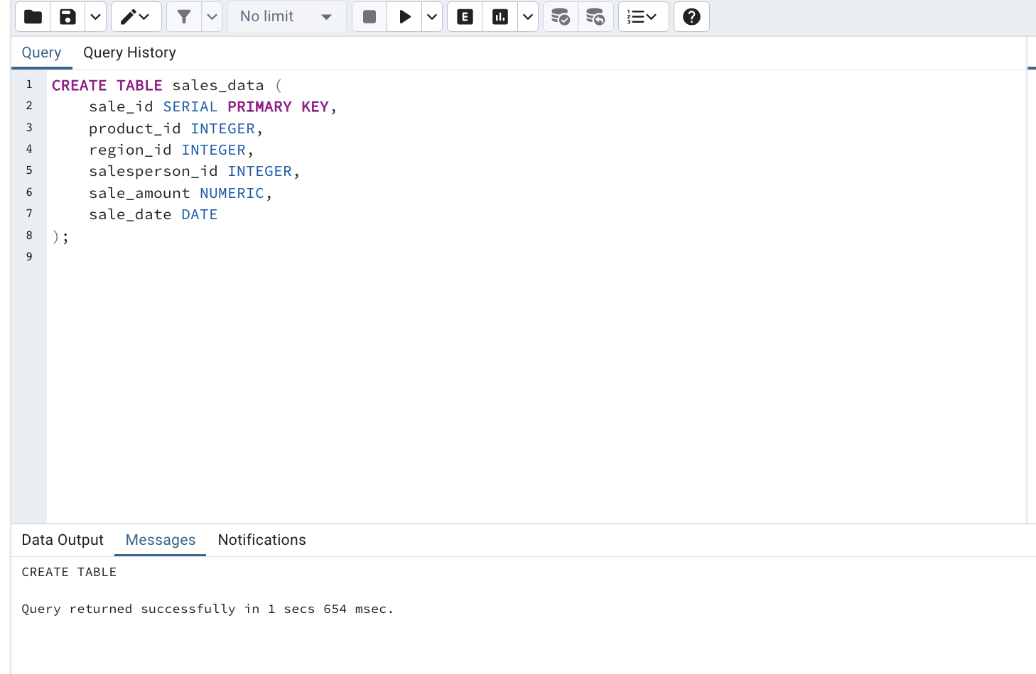

By analyzing the table I can come up with a few variants of partitions that we can use:
- Hashing partitioning using the sale_id column, this is if we don’t have any other possible subgroups that we can create or if we do not want any subgroups but want the partitioning.
- List partitioning using the region_id, if we have a few regions like China, The US, Europe and Africa for example, we can create a list partitioning to separate every order by the region where it was ordered from. This could have some flaws though, because some of the regions can have much more orders then the others, and also it does not exactly specify the country where the order was made from.
- And the final variant is range partitioning using the sale_date as the column, we can separate it to 4 partitions each representing 3 months of the year. This could also have a problem of 1 partition being almost empty when others are full.

Conclusion:
Concluding the analysis I can say that we either use the list partitioning or the range partitioning depending on the factor that we want to analyze, if we want to know what season is the most profitable then its the range partitioning, if we want to see what region gives us the most amount of money, or where we need more storages because there are more orders then we choose the list partitioning. As for the hashing partitioning, I don't think we need to use it here as we are analyzing our sales and by hashing we won't really get the thing we want here, a specific factor that we want to analyze the information from.

Script for creating a table with partitions based on range partitioning

CREATE TABLE sales_data_partitioned (
sale_id SERIAL,
product_id INTEGER,
region_id INTEGER,
salesperson_id INTEGER,
sale_amount NUMERIC,
sale_date DATE,
PRIMARY KEY (sale_id, sale_date)
) PARTITION BY RANGE (sale_date);

CREATE TABLE sales_data_2024_01 PARTITION OF sales_data_partitioned
FOR VALUES FROM ('2024-01-01') TO ('2024-02-01');

CREATE TABLE sales_data_2024_02 PARTITION OF sales_data_partitioned
FOR VALUES FROM ('2024-02-01') TO ('2024-03-01');

CREATE TABLE sales_data_2024_03 PARTITION OF sales_data_partitioned
FOR VALUES FROM ('2024-03-01') TO ('2024-04-01');

CREATE TABLE sales_data_2024_04 PARTITION OF sales_data_partitioned
FOR VALUES FROM ('2024-04-01') TO ('2024-05-01');

CREATE TABLE sales_data_2024_05 PARTITION OF sales_data_partitioned
FOR VALUES FROM ('2024-05-01') TO ('2024-06-01');

CREATE TABLE sales_data_2024_06 PARTITION OF sales_data_partitioned
FOR VALUES FROM ('2024-06-01') TO ('2024-07-01');

CREATE TABLE sales_data_2024_07 PARTITION OF sales_data_partitioned
FOR VALUES FROM ('2024-07-01') TO ('2024-08-01');

CREATE TABLE sales_data_2024_08 PARTITION OF sales_data_partitioned
FOR VALUES FROM ('2024-08-01') TO ('2024-09-01');

CREATE TABLE sales_data_2024_09 PARTITION OF sales_data_partitioned
FOR VALUES FROM ('2024-09-01') TO ('2024-10-01');

CREATE TABLE sales_data_2024_10 PARTITION OF sales_data_partitioned
FOR VALUES FROM ('2024-10-01') TO ('2024-11-01');

CREATE TABLE sales_data_2024_11 PARTITION OF sales_data_partitioned
FOR VALUES FROM ('2024-11-01') TO ('2024-12-01');

CREATE TABLE sales_data_2024_12 PARTITION OF sales_data_partitioned
FOR VALUES FROM ('2024-12-01') TO ('2025-01-01');

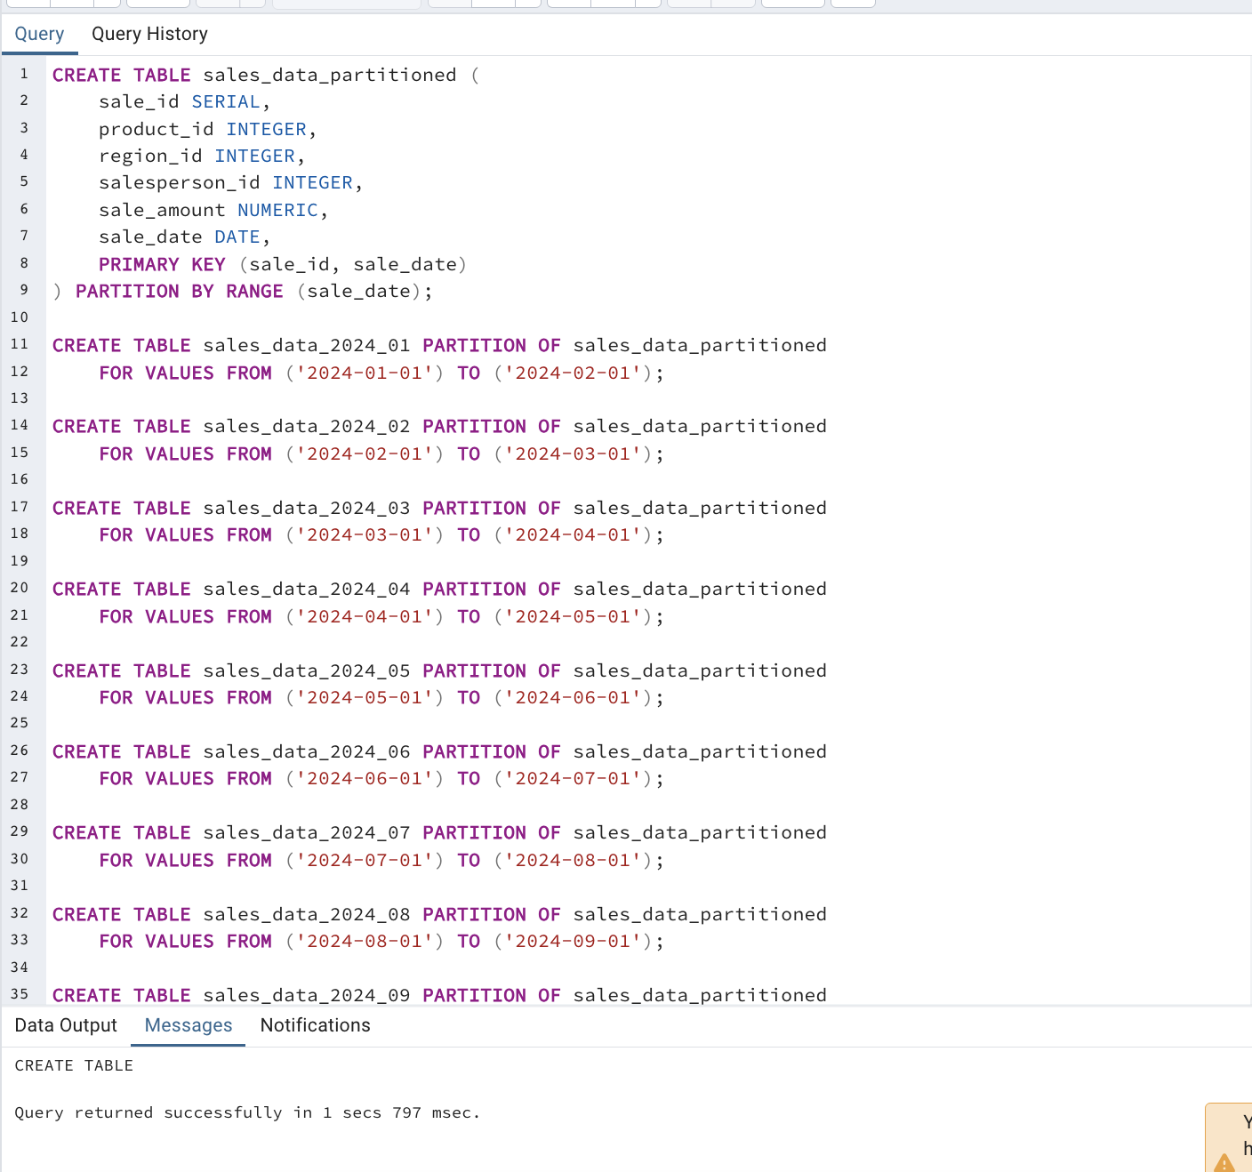

Using the following script we add random data to the table:

DO $$
DECLARE
i INT := 1;
start_date DATE := DATE '2024-01-01';
BEGIN
WHILE i <= 1000 LOOP
DECLARE
product_id INT;
region_id INT;
salesperson_id INT;
sale_date DATE;
BEGIN
product_id := (RANDOM() * 10)::INT + 1;
region_id := (RANDOM() * 5)::INT + 1;
salesperson_id := (RANDOM() * 10)::INT + 1;
sale_date := start_date + (RANDOM() * 365)::INT;

EXECUTE format('
INSERT INTO sales_data_%s
(product_id, region_id, salesperson_id, sale_amount, sale_date)
VALUES
($1, $2, $3, $4, $5)',
to_char(sale_date, 'YYYY_MM')
)
USING product_id, region_id, salesperson_id, (RANDOM() * 900 + 100)::NUMERIC, sale_date;

i := i + 1;
END;
END LOOP;
END $$;

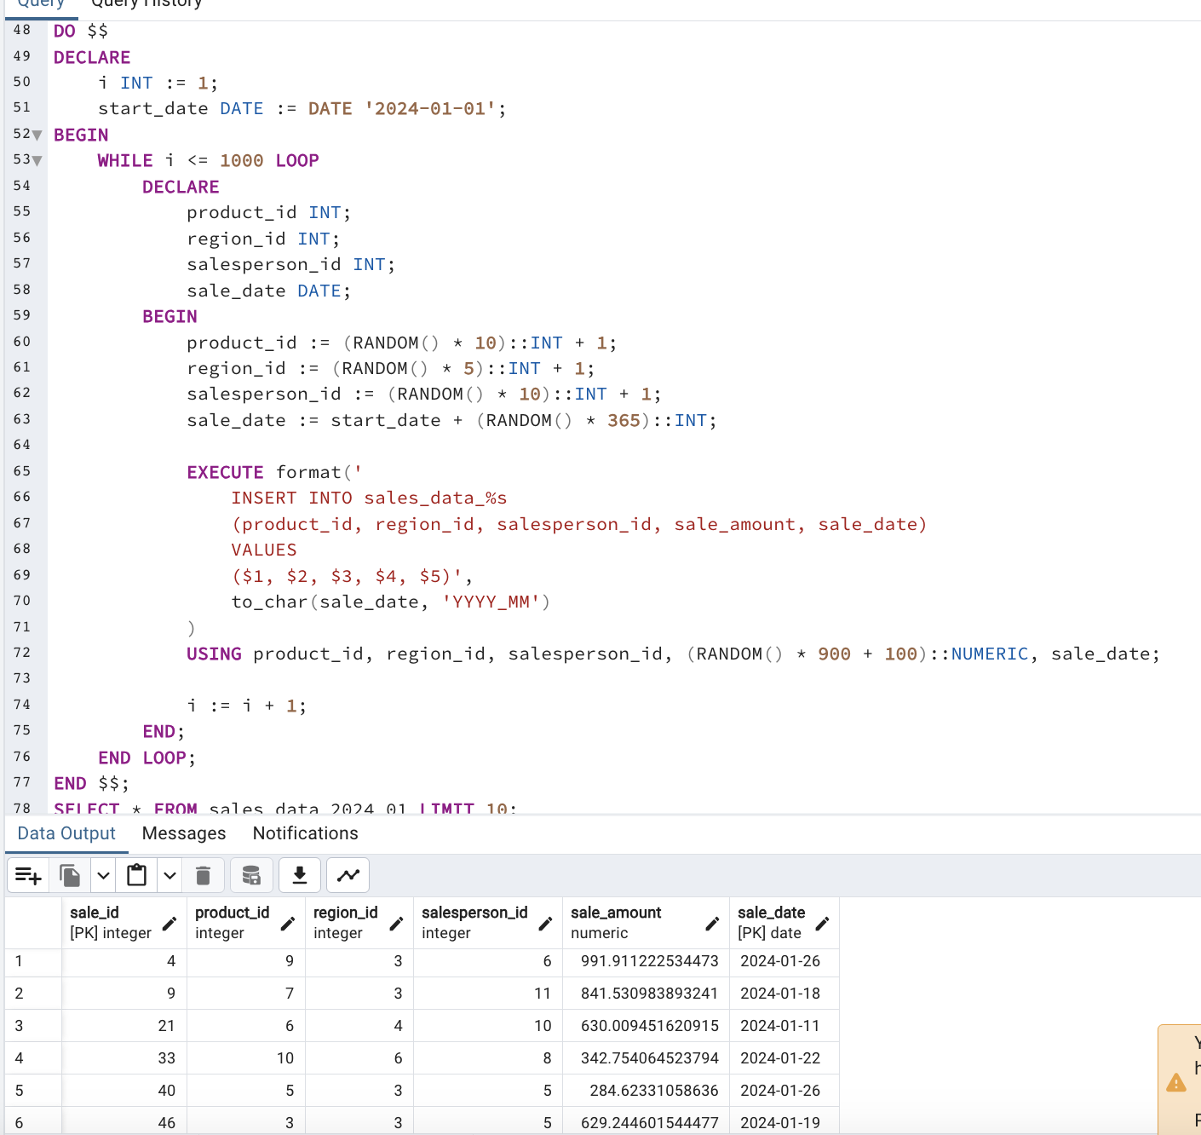

Querying Partitions

1.Retrieve all sales in a specific month

SELECT *
FROM sales_data_2024_05;

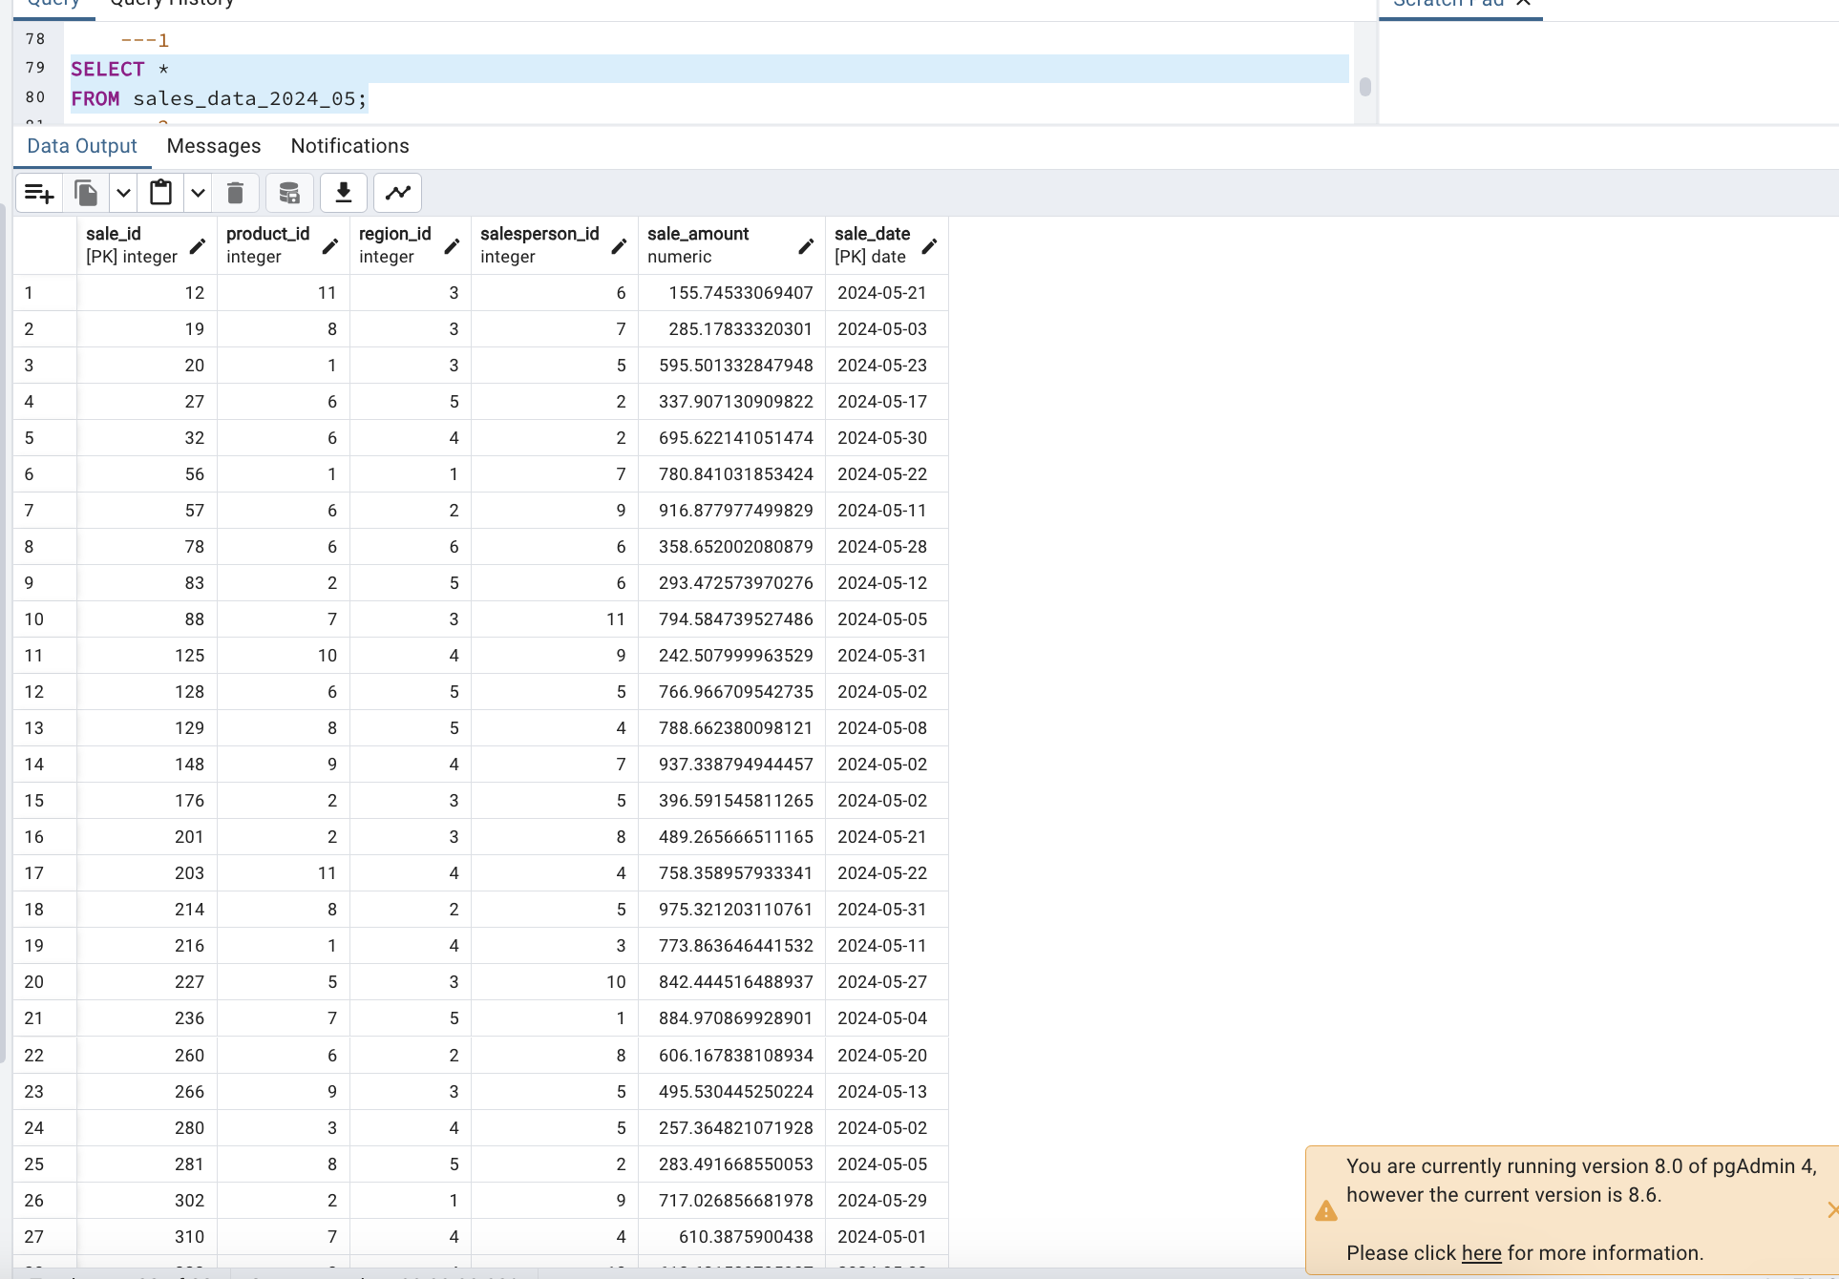

2.Calculate the total sale_amount for each month
SELECT
to_char(sale_date, 'YYYY_MM') AS month,
SUM(sale_amount) AS total_sales
FROM sales_data_partitioned
GROUP BY to_char(sale_date, 'YYYY_MM')
ORDER BY month;

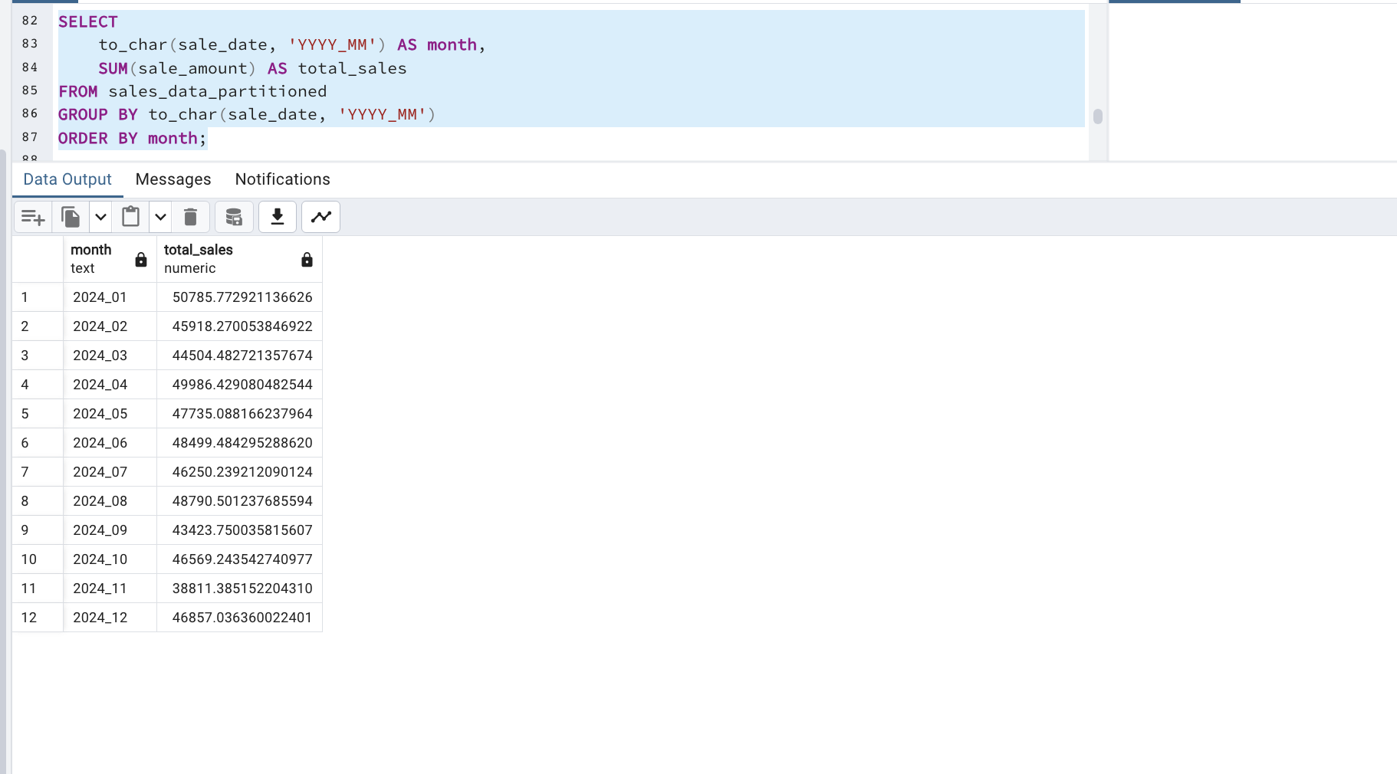

3.Identify the top three salesperson_id values by sale_amount within a specific region across all partitions.

WITH ranked_sales AS (
SELECT
salesperson_id,
SUM(sale_amount) AS total_sales,
RANK() OVER (ORDER BY SUM(sale_amount) DESC) AS sales_rank
FROM
sales_data_partitioned
WHERE
region_id = 1
GROUP BY
salesperson_id
)
SELECT
salesperson_id,
total_sales
FROM
ranked_sales
WHERE
sales_rank <= 3;
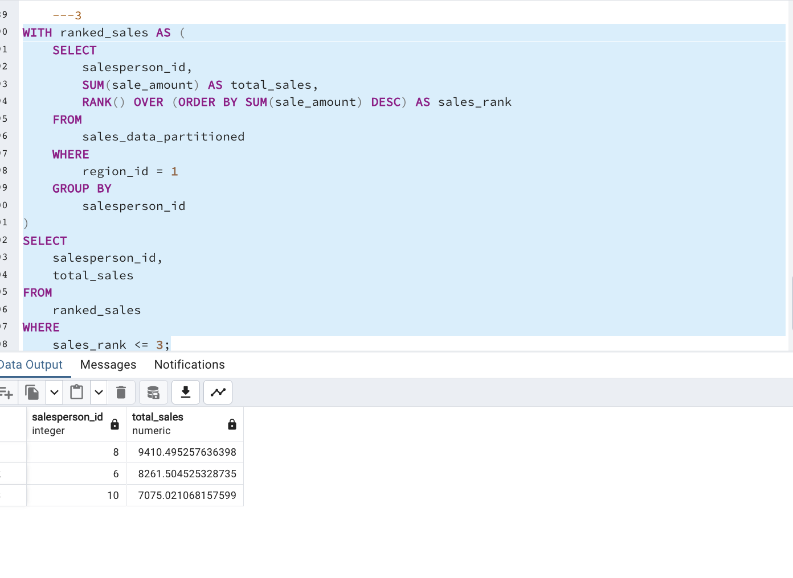
Define a maintenance task to drop partitions older than 12 months and create new partitions for the next month.

The script below will be called at the beginning of each month. By setting the current date as the date when it will be called it will remove the current_date - 12 months partition, which basically means if today is May then it will remove the May partition of last year and create a partition of May (if it doesnt already exist for some reason ( in our case as I created the database with 12 months of 2024) )

CREATE OR REPLACE FUNCTION manage_partitions() RETURNS VOID AS
$$
DECLARE
current_date DATE := NOW()::DATE;
cutoff_date DATE := current_date - INTERVAL '12 months';
next_month_start DATE := DATE_TRUNC('month', current_date) + INTERVAL '1 month';
next_month_end DATE := next_month_start + INTERVAL '1 month';
BEGIN

EXECUTE format('DROP TABLE IF EXISTS sales_data_%s', TO_CHAR(cutoff_date, 'YYYY_MM'));

EXECUTE format('CREATE TABLE IF NOT EXISTS sales_data_%s PARTITION OF sales_data_partitioned
FOR VALUES FROM (%L) TO (%L)',
TO_CHAR(next_month_start, 'YYYY_MM'), next_month_start, next_month_end);
END;
$$
LANGUAGE plpgsql;

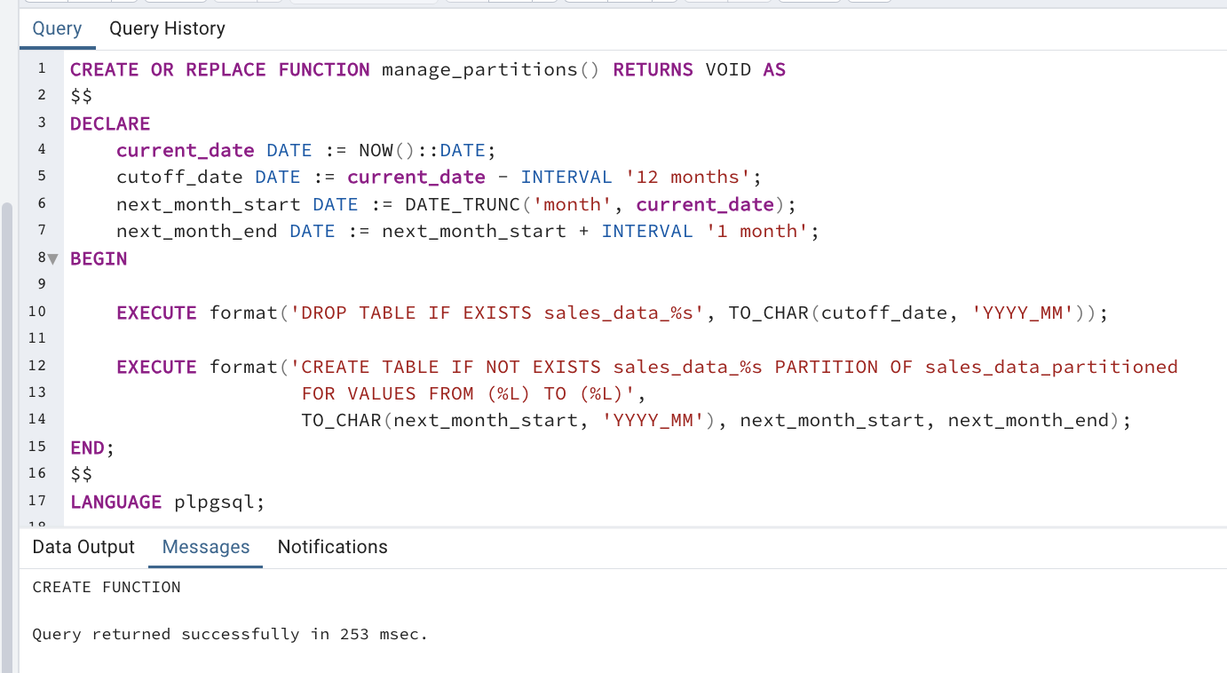

To check if it works we can add the May of last year and call the function:

CREATE TABLE IF NOT EXISTS sales_data_2023_05 PARTITION OF sales_data_partitioned
FOR VALUES FROM ('2023-05-01') TO ('2023-06-01');

SELECT manage_partitions();

